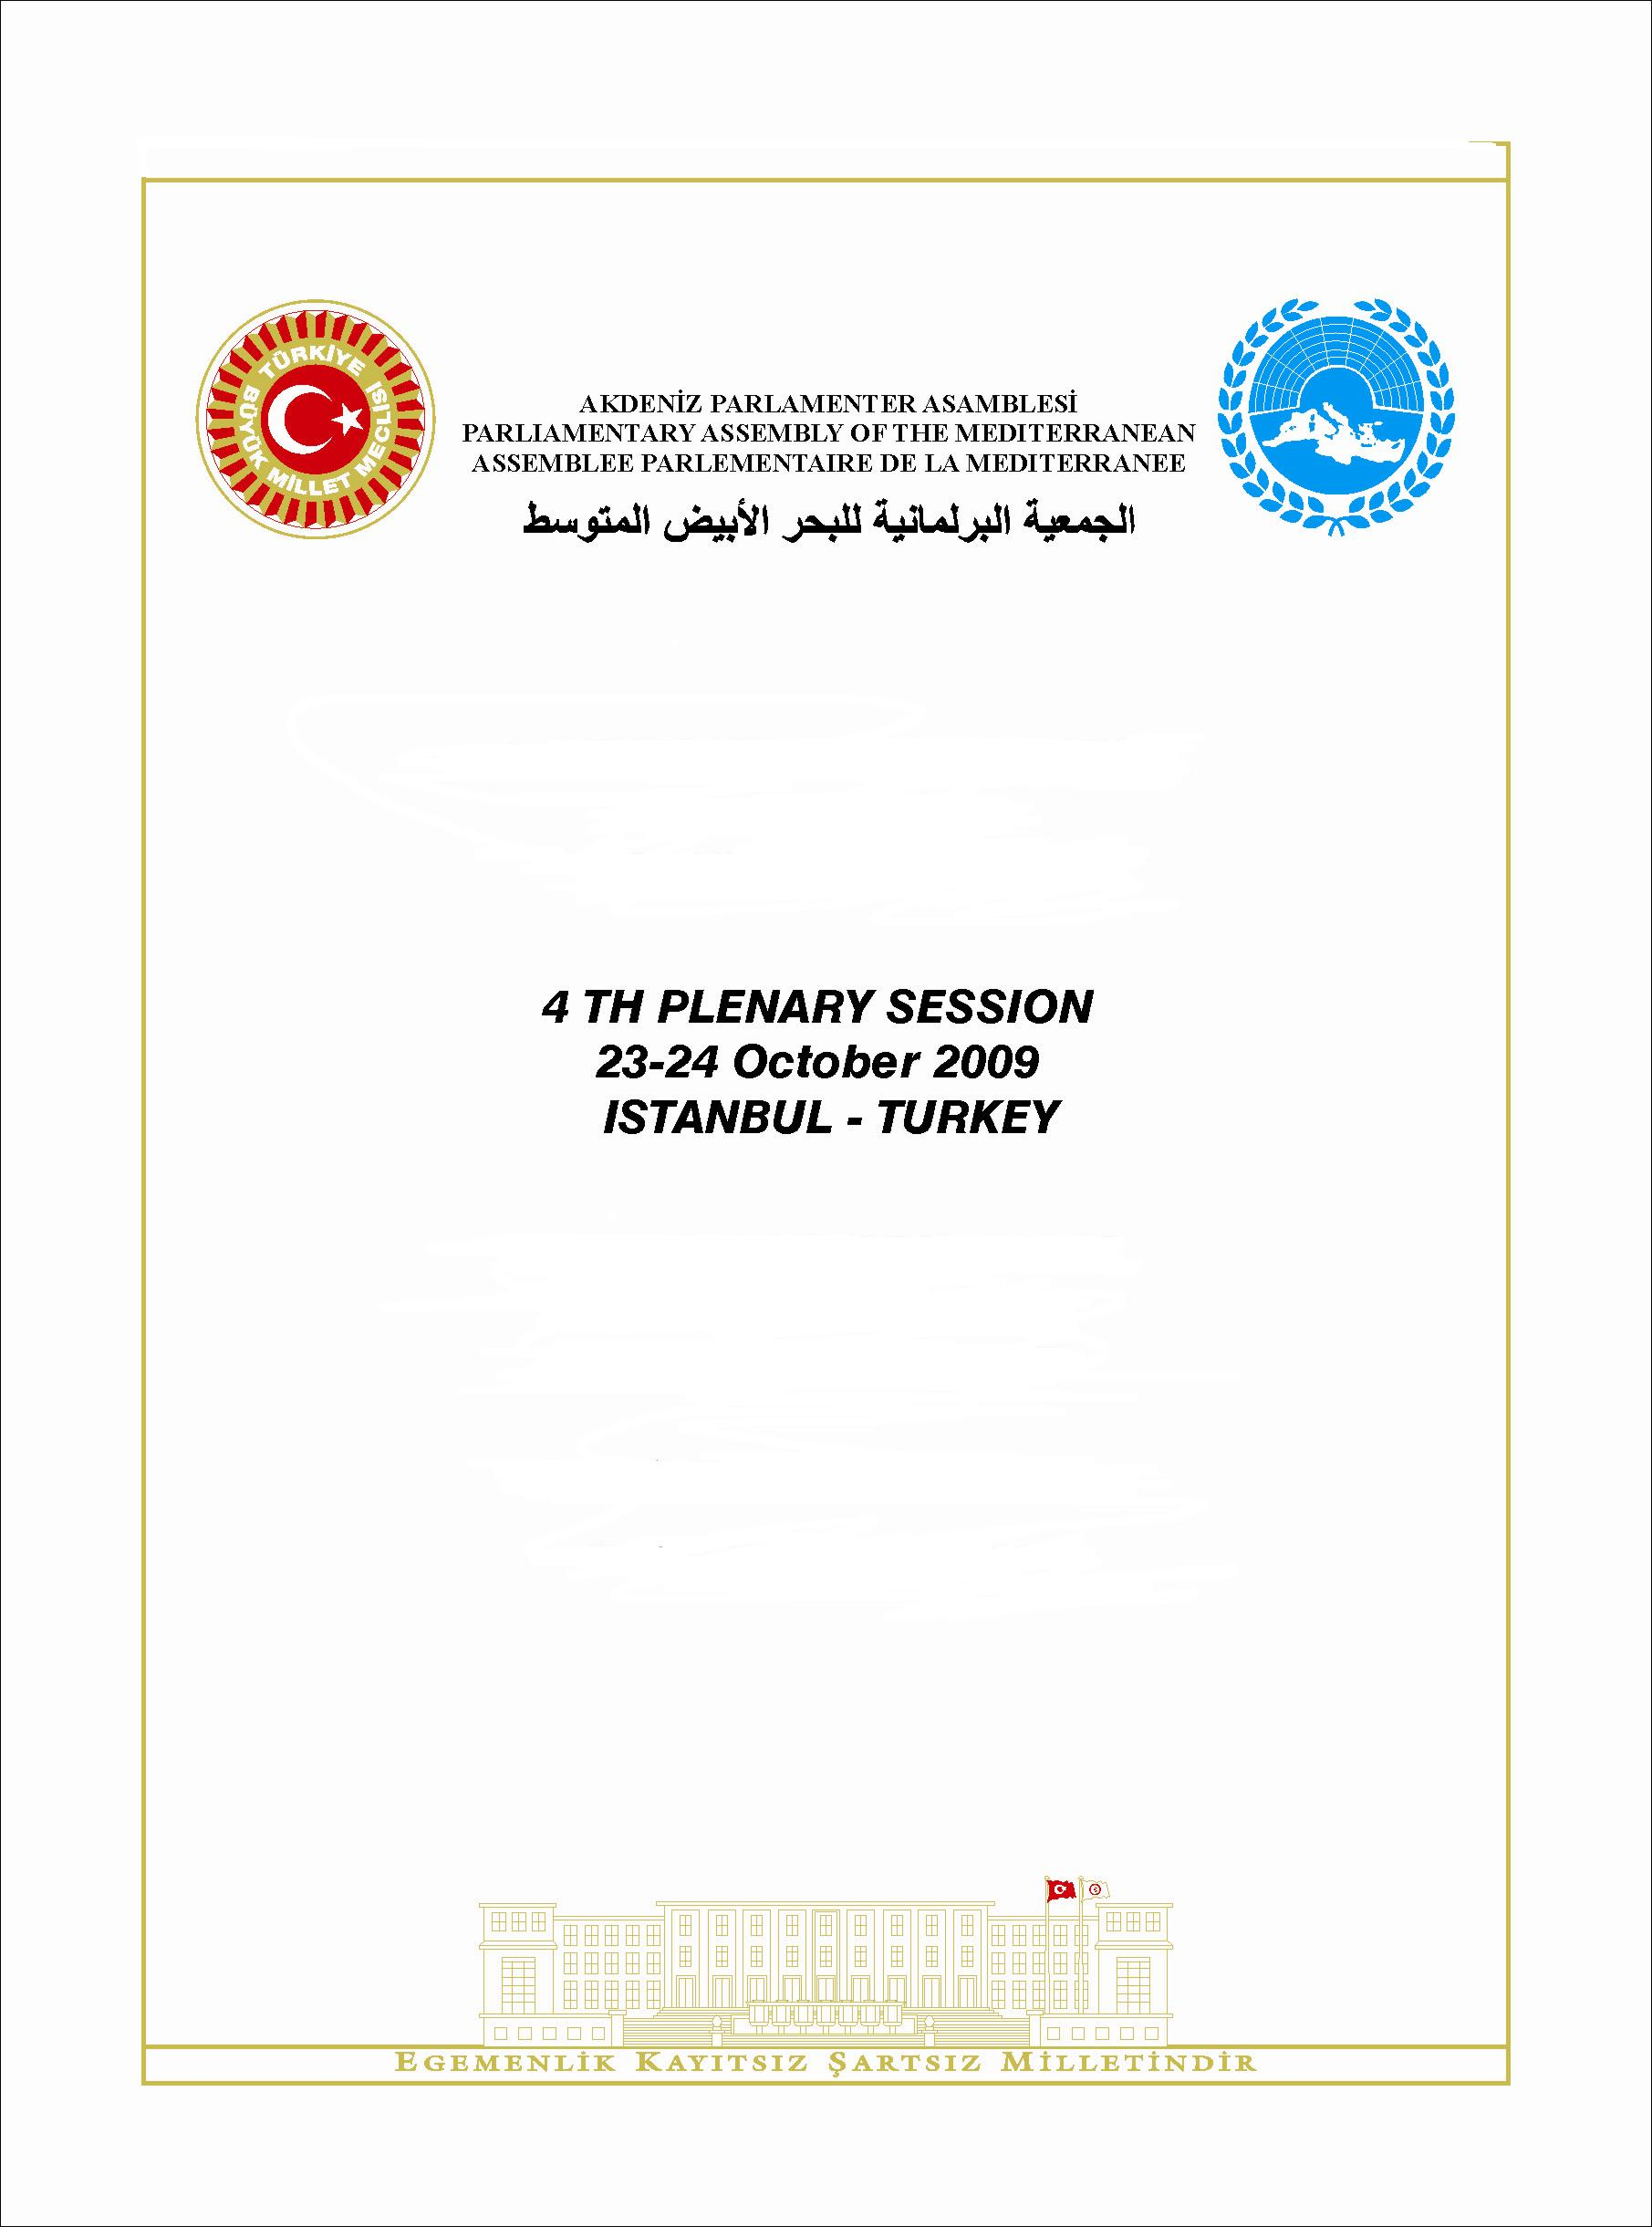

Parliamentary Assembly of the Mediterranean
Turkey, 23-25 October 2009

Message from H.E. Mr. Mehmet Ali ŞAHİN, Speaker of the Grand National Assembly of Turkey

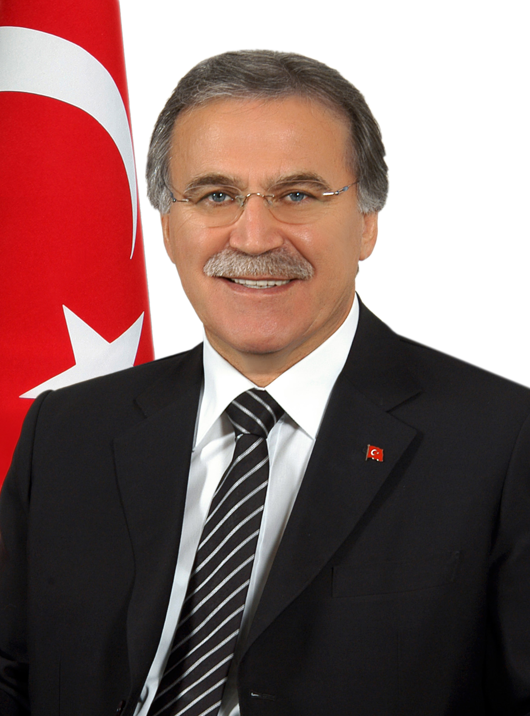
On behalf of the Grand National Assembly of Turkey, I would like to welcome all distinguished guests to Istanbul, 2010 European Capital of Culture, a city which brings civilizations together.

It gives us great pleasure to host the “4th Plenary Session of the Parliamentary Assembly of the Mediterranean”, where colleagues from around the region gather to finalize the activities of the previous year and determine the calendar for 2010.

The Grand National Assembly of Turkey aims at creating an international atmosphere in which countries of the world enjoy peace and prosperity based on good relations, stability, and cooperation.

For this purpose, our Parliament gives utmost importance to enhancing relations at all levels with parliaments that represent nations and strives for conducting an efficient parliamentary diplomacy.

The Grand National Assembly of Turkey, which believes in the importance of the contribution of parliaments in providing solutions to today’s problems and preserving peace and stability, actively contributes to organizations instituted to this end.

The Mediterranean region hosted many civilizations throughout the history of mankind and played a unique role in the improvement of the democratic system. The most obvious sign of this is that the world’s oldest democratic parliament is located in Patara, a small town affiliated to Kaş, a district of the city of Antalya.

As the parliaments of the Mediterranean region have such a longstanding democratic history, I strongly believe that the work we will perform together for our common future is of great importance.

In today’s world where all local and global components are more and more interrelated, Mediterranean parliamentary diplomacy offers a fresh approach to international diplomacy, based on its common and rich historical heritage.

Turkey has always supported and will continue to support initiatives towards enhancing cooperation and dialogue in the region.

Distinguished Colleagues, I wish that you will enjoy your time in Istanbul, bridge among different faiths and cultures and with a history of thousands of years.


Mehmet Ali ŞAHİN

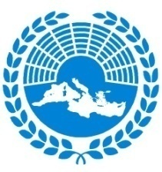 | PARLIAMENTARY ASSEMBLY OF THE MEDITERRANEAN  Assemblee parlementaire de la Mediterranee  الجمعيـــة البرلمانيــة للبحـــر الأبيــض المتوســـــــط

St. Julians, 26 August 2009

CONVOCATION TO THE IVth PLENARY SESSION OF THE PARLIAMENTARY ASSEMBLY OF THE MEDITERRANEAN

23-24 October 2009, Conrad Hotel, Istanbul (Turkey)

Mr./Madam President,

We are pleased to inform you that, at the kind invitation of H.E. Mehmet Ali Şahin, President of the Grand National Assembly of Turkey, the IVth Plenary Session of the Parliamentary Assembly of the Mediterranean will be held at the Conrad Hotel, Istanbul (Turkey), on 23-24 October 2009.

Purpose of the Plenary Assembly

During the Plenary Session of the Assembly in Istanbul, delegates shall adopt reports and resolutions prepared by the three Standing Committees and their respective Special Task Forces and Ad Hoc Committees, of PAM and voted upon during our last Standing Committee meetings held in Lisbon, Portugal from 24-26 June 2009.

Information for Delegates

All information regarding the Plenary Session shall shortly be forwarded to you together with the formal invitation. Delegates are called upon to give particular attention to the necessary requirements relating to composition of delegations, the issuance of visas and hotel accommodation.

First meeting of the Secretaries General of the PAM Members

Please also note that the IVth Plenary Session will be followed by the 1st meeting of the Secretaries General of the PAM Members on 25 October, and the Secretary General of your parliament has been invited to participate.

Please accept, Mr./Madam President, the assurances of our highest consideration.

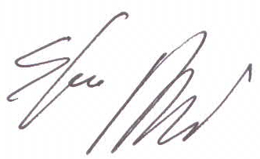
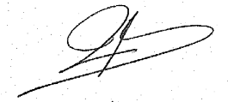

Rudy Salles Dr. Sergio Piazzi
President Secretary General

Palazzo Spinola, St. George’s Road, St. Julians, STJ 3207 Malta
Tel.: 00356 22484200, Fax: 00356 22484215
e-mail: secretariat@apm.org.mt website: www.apm.org.mt

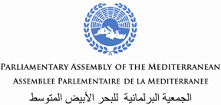
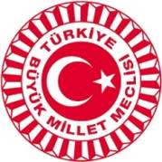

4th PLENARY SESSION

Conrad Hotel, Istanbul
ISTANBUL (TURKEY) 23 - 24 October 2009

Draft Agenda
Friday 23 October
10-12.30 PAM Bureau Meeting

Lunch break (free)

2.00 Registration

2.15 Official opening of the IVth Plenary Session

Welcome Address by H.E. Mr. Mehmet Ali Şahin, Speaker of Grand National Assembly of Turkey
Welcome Address by H.E.Mr. Rudy Salles, PAM President (France)

Inaugural addresses by H.E.Mr. Recep Tayyip Erdoğan, Prime Minister of Turkey

3.00 Coffee break and Family picture

3.30 Continuation of Inaugural addresses by
H.E.Mr. Nasser S. Judeh, Minister of Foreign Affairs of Jordan (Invited)

H.E.Mr. Robert Walter, President of the European Security and Defence Assembly,
Assembly of WEU
H.E.Mr. Abdirahin Abdi, Speaker, East African Legislative Assembly
H.E.Mr. Carlos Jimenez Macias, Parliamentary Confederation of the Americas (Invited)
Adoption of the agenda
4.00 Presentation of the work of the 1st Standing Committee (Political and Security-related Cooperation),
Hon. José Junqueiro, PAM Vice President and President of the 1st Standing Committee (Portugal)

Keynote Address by H.E. Serge Telle, Ambassador for the Union for the Mediterranean

Briefing on a PAM Bureau delegation visit to NYC and Washington DC (Sept/Oct 2009), H.E. Mr. Rudy Salles, PAM President (France)
4.30 Adoption of the following Resolutions and Reports:
- Middle East : Hon. George Vella (Malta)
- Organized Crime : Hon. Angela Napoli (Italy)
- Reflexion Group on Terrorism : Hon. Askin Asan (Turkey) / Hon. Tayseer Quba’a (Palestine)

5.30 Identification of key activities, tentative dates and venues for the 1st Standing Committee
and its Special Task Forces in 2010

5.45 PAM Communication & Outreach Strategy, Hon George Vella (Malta)

6.00 A.O.B.

6.45 Departure from the hotel by bus

7.30 Dinner hosted by H.E. Mr. Mehmet Ali Şahin, Speaker of Grand National Assembly of Turkey
Çırağan Palace Kempinski

Saturday 24 October
9.00 Presentation of the work of the 2nd Standing Committee (Economic, Social and Environmental Cooperation), Hon Suleiman Ghneimat, PAM Vice President, President of 2nd Standing Committee (Jordan)

Keynote address by: Dr. Sima S. Bahous, Assistant Secretary General, League of Arab States

9.45 Adoption of the following Resolutions and Reports
- Energy: Hon. Mohammed Abou El Enein (Egypt)

Regulatory approach and Climate Change challenges, M. Carlo Crea, Secretary General, MEDREG ∗

- Water: Hon Jacques Blanc (France)

Hon. Bernard Marquet, Member of the Parliamentary Assembly of the Council of Europe (PACE)

- Environment and Climate Change: Hon. Elissavet Papadimitriou (Greece), Presented by Hon Jacques Blanc (France)

11.00 Coffee break

11.15 Adoption of the following Resolutions and Reports

- Disaster Management: Hon. José Junqueiro (Portugal)

- Small and Medium-Sized Enterprises: Hon. Ridha Bouargoub (Tunisia), Presented by Hon Juri Franco (Slovenia)

12.00 Identification of key activities, tentative dates and venues for the 2nd Standing Committee
and its Special Task Forces in 2010

12.15 Report by the PAM Secretary General on the financial situation of the Assembly

12.30 Lunch Break (free)

2.00 Presentation of the work by the 3rd Standing Committee (Dialogue among Civilizations and Human Rights), Hon. Abdelkader Fedala, PAM Vice President (Algeria)

Keynote addresses by
Mrs. Karen AbuZayd, UNRWA Commissioner General

2.45 Adoption of the following Resolutions and Reports

- Dialogue of Cultures and Religions: Hon. Sónia Sanfona (Portugal), Presented by Hon Justyne Caruana (Malta)
Prof Dr Mahmud Erol Kilic, Secretary General of PUIC
- Migrations: Hon. Mahmoud Muhaidat (Jordan)
- Gender and Equality Issues : Hon. Askin Asan (Turkey) / Hon. Houda Bizid Blaiech (Tunisia)

4.00 Coffee break and signature of the PAM Letter of Engagement on Intercultural Dialogue

4.30 Identification of key activities, tentative dates and venues for the 3rd Standing Committee
and its Special Task Forces in 2010

5.00 Laureates of the “2009 PAM Prize”

5.15 Closure of the IVth Plenary Session

Press conference

6.30 Departure from Hotels by bus for yacht tour on Bosphorus

7.00 Yacht tour and Dinner hosted by Hon Askin Asan, Head of the Turkish delegation to PAM and Vice President of 3rd Standing Committee

1st Meeting of the Secretaries general of the PAM Member Assemblies

Conrad Hotel, Istanbul
ISTANBUL (TURKEY) 25 October 2009

Draft Agenda∗
Sunday 25 October
9.30 Registration
10-1pm 1st Meeting of the Secretaries General of the Member Assemblies of PAM

Welcome by Mr. Ali Osman Koca, Secretary General of the Grand Assembly of Turkey

Welcome by Mr Sergio Piazzi, PAM Secretary General

Introductory Address by Hon Rudy Salles, PAM President (France)

Adoption of the agenda
“The PAM, its activities and its ambitions” by Sergio Piazzi, PAM Secretary General
Roundtable on “Best practices and lessons learned” (presented by a number of national delegations) on how to:
- Provide best support national delegations,
-Enhance cooperation among Member Assemblies,
- Create synergies of actions between the PAM Secretariat and the secretariats of the Member Assemblies,
- Increase PAM visibility and impact at national and regional levels.
“Cooperation prospect among Mediterranean Parliaments, Towards a structured cooperation of the Secretaries General”, Alain Delcamp (France)

“Relations between the Parliamentary Assembly of the Council of Europe and Parliaments of Member States - functionning of national delegations”, Mr Wojciech Sawicki, Director General of PACE

1 pm Departure by bus

1.30pm Lunch hosted by Mr. Ali Osman Koca, Secretary General of the Grand Assembly of
Turkey Feriye restaurant

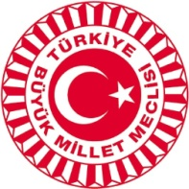

GENERAL INFORMATION

GEOGRAPHICAL LOCATION OF THE CITY OF ISTANBUL
In its south stretches Marmara Sea and in its north is Black Sea. Its west part is in Europe and east part is in Asia. The important waterline dividing Istanbul into two is the Bosphorus… The only alternative to reach the Aegean Sea and the Meditteranean Sea, therefore to open sea is to use Istanbul and the the Bosphorus…
Istanbul is both the nearest Asian city to Europe and the nearest European city to Asia. What adds to Istanbul’s significance is its being a port city and all trade paths’ passing through the city for thousands of years…
Turkey is located in the northern hemisphere between the 36º - 42º northern parallel and the 26º - 45º eastern meridian.
It has an area of 783,562 square km.
OFFICIAL LANGUAGE

Turkish is the only official language in Turkey.
TIME ZONE
Standard Time Zone :UTC / GMT + 2 hours
WEATHER
There is no definite climate type for the whole Istanbul Province. Because of its geographic location and physical geographic features, it carries different climate features than the ones in the same latitudes.
ISTANBUL | Min (Cº) | Max (Cº) | Rain (cm) | Min (F) | Max (F) | Rain (inch)
October | 13 | 20 | 8.1 | 55 | 68 | 3.2
Fall (September / October) is a splendid time in Istanbul. Being not too hot or too cold it is actually the better summer. You may enjoy your boat-trip and join all the cheerful people on the streets, terraces and Cafés. Usually rainfall in Istanbul can be short-lived.

VENUE

All the meetings of the Fourth Plenary Session will be held at the “Junior Ballroom”.

CONRAD ISTANBUL
Yıldız Caddesi,Beşiktaş 34353 İSTANBUL/TURKEY/TURQUIE
Tel. : +90-212-227 30 00
Fax : +90-212-258 92 41
e-mail : sebnem.bayazit@conradhotels.com
URL : http://istanbul.conradmeetings.com/isthcci/general.html

Any question of the delegates will be answered by the staff before and during the meetings at the information desk.

ORGANISERS

Parliamentary Assembly of the Mediterranean / Assemblé Parlamentaire de la Mediterranée

Celiné Cervi
Palazzo Spinola
St.George’s Road
St Julians, STJ 3207 Malta

Tel. : +356-992 133 83
Fax : +356-224 842 15
e-mail : cervi@apm.org.mt

Grand National Assembly of Turkey / Assamblèe Parlamentaire de la Mèditerranè

Mr.Mesut Arslanbek Ms.Derya Baykal

TBMM TBMM
External Relations and Protocol Dept. External Relations and Protocol Dept.
06543 Ankara , Turkey 06543 Ankara, Turkey

Tel. : +90-312-420 67 57 Tel. : +90-312-420 67 45
Fax : +90-312-420 67 68 Fax : +90-312-420 67 56

e-mail : bab@tbmm.gov.tr e-mail : derya.baykal@tbmm.gov.tr

INTERPRETATION

Simultaneous interpretation will be available for the meetings in English, French, Arabic and Turkish.

CREDIT CARDS

All major credit cards are acepted at hotels, restaurants and shops.
PARTICIPATION AND REGISTRATION

The delegates of respective member countries are requested to fill in all the forms enclosed to this booklet and return them in due time.

REGISTRATION

The registration desk, located at the entrance Junior Ballroom of Conrad İstanbul will be opened in the afternoon, at 5.00 pm on Thursday, 22 October 2009. The delegates may collect their badges and meeting documents from the the registration desk.

VISA REQUIREMENTS

Visas will be issued by embassies or consular missions of Turkey, a list can be found on the Turkish Ministry of Foreign Affairs web-page : www.mfa.gov.tr .

ARRIVAL AND DEPARTURE IN ISTANBUL

The welcome service will assist the delegates at Conrad İstanbul. Any means of transportation will not be provided from or to the İstanbul Atatürk Airport by the organisers.

TRANSPORTATION

Participants are kindly requested to take a taxi or use public transport between the airport and hotels.

TAXI

From / to Atatürk Airport - Hotels ; approx. 30 minutes, 25.-€

PUBLIC TRANSPORT

From / to Atatürk Airport - Taksim Navette (HAVAŞ) approx: 4.-€
(Every 30 minutes – Tickets can be purchased in the buses)
and then
Taksim - Hotel (by taxi) 5.-€

BADGES

Badges will be submitted to delegates upon their registration. All the participants are quested to wear the badges during all the activites.

Blue : Parliamentarians
Yellow : Accompanying staff / Advisors / Secretariat
White : Accompanying persons
Orange : Assembly organisers and supporting staff
Green : Media
Red : Security

MEDIA

Media members are required to fill in the accrediation form and forward it before the deadline.
Complementary information will be supplied to the media members at the time of their registration.

4th PLENARY SESSION OF PARLIAMENTARY ASSEMBLY of the MEDITERRANEAN
23-25 October 2009
İstanbul, Turkey

ACCOMPANYING PERSONS PROGRAMME

FRIDAY, OCTOBER 23rd 2009

10:00 Departure by bus from the Conrad Hotel İstanbul to “Dolmabahçe
Palace”:

During the six hundred years of Ottoman rule, the seat of the empire changed several times, from Bursa to Edirne and later to İstanbul. The site of the imperial 'palace', center of Ottoman government, changed also over the centuries in İstanbul itself. The earliest palace to post-date the Ottoman conquest of İstanbul was the Saray-ı Atik-i Âmire (the Old Palace - 1453/1478). After which the Ottoman imperial seat of government removed, at some point, to Topkapı Palace, known as the Saray-ı Cedid-i Âmire (Built between 1478 and 1856). In subsequent eras, the sultans inhabited Topkapı, the Çırağan Palace, the shore palace at Beşiktaş and Beylerbeyi Palace at various intervals, until the completion of Dolmabahçe Palace in 1856, when this became the official Ottoman seat.

In 1877 the sultan moved once again, this time to Yıldız Palace, where the Ottoman court remained until 1909. From that date until the dissolution of the sultanate in 1922, Dolmabahçe regained its status as official imperial residence. The Palace of Dolmabahçe, completed in 1856, is the third largest Ottoman Palace in İstanbul. It embodies, in its very form the social and cultural structure of the period, of which it is stylistically typical. Dolmabahçe was a prestigious addition to the urban silhouette of İstanbul built on a prominent site at the entrance to the Bosphorus. It stands at a focal point in the fast growing 19th century city, and was built at a time of increasing enthusiasm for all things occidental...

Dolmabahçe Palace has 285 rooms, 46 lounges, 6 Turkish Baths, 68 toilets, 45.000 m² of use area and 4454 m² of laid out carpet.

12:30 Guest will return to hotel by bus

4th PLENARY SESSION OF PARLIAMENTARY ASSEMBLY of the MEDITERRANEAN
23-25 October 2009
İstanbul , Turkey

ACCOMPANYING PERSONS PROGRAMME

SATURDAY, OCTOBER 24th 2009

14:00 Departure by bus from the Conrad Hotel İstanbul to “Grand Bazaar”:

İstanbul Grand Bazaar (Kapali Çarsi, or Covered Market) is Turkey's largest covered market offering excellent shopping: beautiful Turkish carpets, glazed tiles and pottery, copper and brassware, apparel made of leather, cotton and wool, meerschaum pipes, alabaster bookends and ashtrays, and all sorts of other things.
It has been claimed that it has 4000 shops. Because of consolidation and replacement of shops by restaurants and other services the number is certainly lower, but you get the idea: it has lots of shops. Not all of them, by the way, are for tourists; locals shop here as well, lending a welcome dose of authenticity.

17:00 Guests will return to the hotel by bus

4th PLENARY SESSION OF PARLIAMENTARY ASSEMBLY of the MEDITERRANEAN
23-25 October 2009
İstanbul , Turkey

EXCURSION PROGRAMME
SUNDAY, OCTOBER 25th 2009

10:00 Departure by bus from the Conrad Hotel İstanbul to
“Turkish – Islamic Arts Museum”:

Turkish and Islamic Works Museum
- Turkish and Islamic Works Museum has been awarded with the Special Jury Award of Museum of the Year Competition of the European Council in 1984 and with the prize given by European Council - Unesco for its studies for making the children love the culture inheritance.
Turkish and Islamic Works Museum, that is among the important museums of the world in its class has works from almost all periods and all types of Islamic art with its collection exceeding forty thousand works.

Blue Mosque
- This mosque was built by Sultan Ahmet I during 1609-1616 in the square carrying his name in Istanbul. The architect is Sedefkar Mehmet Aga. It is the only mosque in Turkey with six minarets. The mosque is 64 x 72 m in dimensions. The central dome is 43 m in height and is 33.4 m in diameter. 260 windows surround the mosque. Due to its beautiful blue, green and white tilings it has been named the "Blue Mosque" by Europeans. The inscriptions were made by Seyyid Kasim Gubari.

Hagia Sophia
-Hagia Sophia is considered a unique monument in world architecture, and it's magnificence and functionality has been a good example in construction of countless Ottoman mosques. Hagia Sophia with its exceptional history constitutes a synthesis between east and west. This monument is one of the wonders of the world that has remained intact until the present day. One can find many attractions in Hagia Sophia - interesting forms of Byzantine architecture, mosaics of the Christian period as well as structures added during the Ottoman era.

Topkapı Palace
- Topkapı Palace is located on the promontory of the historical peninsula in Istanbul which overlooks both the Marmara Sea and the Bosphorus. The walls enclosing the palace grounds, the main gate on the land side and the first buildings were constructed during the time of Fatih Sultan Mehmet (the Conqueror) (1451 - 81). The palace has taken its present layout with the addition of new structures in the later centuries. Topkapi Palace was the official residence of the Ottoman Sultans, starting with Fatih Sultan Mehmet until 1856, when Abdulmecid moved to the Dolmabahce palace, functioned as the administrative center of the state. The Enderun section also gained importance as a school.

14:00 Lunch at “Konyalı Restaurant” at Topkapı Palace Museum

15:00 Return to the hotel

 Embassies and Consulates / Ambassades et Consulats
Albany  Albanie | H.E..Altin KODRA  Ambassador | Simon Bolivan Bulvarı, Ebuziya Tevfik Sokağı, No.17,Çankaya, Ankara  embassy.ankara@mfa.gov.al | Tel.:+90-312-441 61 03-04  Fax: +90-312- 441 61 09
 | H.E. Elvira ISUFI  Consul General | İsmet İnönü Cad., Deniz apt., No: 22/6, Gümüşsuyu, Taksim, İstanbul | Tel.: +90-212-244 32 56-57  Fax: +90-212- 244 23 38
Algeria/Algérie | H.E. Smaïl ALLAOUA  Ambassador | Şehit Ersan Cad., No: 42, 06680 Çankaya, Ankara  cezayirbe@yahoo.fr | Tel.: +90-312-468 7719 –  +90-312- 428 80 37  Fax: +90-312-468 75 93
 | H.E.Djamel Dine HAMOUT  Consul General | Gazeteciler Sitesi 23 Temmuz Meydanı No: 7, 34394 Şişli /İstanbul  istconsalg@yahoo.fr | Tel.:+90-212-356 95 16  Fax: +90-212-356 95 15
Bosnia-Herzegovina  Bosnie-Herzégovine | H.E. Dragoljub LJEPOJA  Ambassador | Turan Emeksiz Sokak, Park Blokları, B-Blok No. 3/9-10, G.O.P.,  bh_emb@kablonet.com.tr | Tel.:+90-312- 427 36 02-03  Fax: +90-312-427 36 04
 | H.E. Brane PECANAC  Consul General | Dikilitaş mah., Yeni Gelin Sok., No: 24, Kat.3, Beşiktaş, İstanbul  Telefon: (212) 236 69 34 , 236 68 92 Faks: (212) 236 28 31  gco-tr-ist@ttnet.net.tr | Tel.: +90-212-236 69 34 ,  236 68 92  Faks: +90-212-236 28 31
Croatia/Croatie | H.E. Bay Gordan BAKOTA  Ambassador | Kelebek Sokak 15/A, 06700 G.O.P., Ankara  ankara@mvpci.hr  www.tr.mvp.hr | Tel.:+90-312- 446 08 31  446 94 60  437 95 44  Fax:+90-312- 446 47 00
 | H.E. Damir PERINCIC  Consul General | Meşrutiyet Cad. 163/2 Tepebaşı- Beyoğlu, 34420 İstanbul  gkrh.istanbul@mvpei.hr | Tel.: +90-212-293 54 67-68  Fax: 0212 293 54 76
Egypt/Egypte | Dr. Alaa Eldin A. Shawky ELHADIDI  Ambassador | Atatürk Bulvarı. 126, 06680 Kavaklıdere, Ankara | Tel.:+890-312- 426 10 26  468 22 40  426 61 32  Fax :+90-312-427 00 99
 | H.E.Iman Mostafa A.AHMED  Consul General | Konaklar Mah. Akasyalı sokak, No: 26 4.Levent/ İstanbul  ecg_istanbul@yahoo.com | Tel.: +90-212-324 21 60  324 21 33  Fax: +90-212-324 22 04
France | H.E. Benard Jean  Ambassador | Paris Cad. No.70 Kavaklıdere-Ankara  Ambaank@. Yahoo.fr  http://www.ambafrance-tr.org | Tel.: +90-312-455 45 45  Fax:+90-312- 455 45 27
 | H.E.Christophe PEAUCELLE | İstiklal Caddesi No: 8, 80090 Taksim, İstanbul  mail@consulfrance-istanbul.org | Tel.: +90212-334 87 30  Fax: +90-212-334 87 31
Greece/Gréce | H.E. Fotios-Jean XYDAS  Ambassador | Zia Ur Rahman Cad., No: 9-11, 06700 G.O.P., Ankara  greekemb@superonline.com, greekembassy@ttnet.net.tr | Tel.:+90-312- 448 08 73  448 22 49  Fax:+90-312- 446 31 91
 | H.E. Alexandros ALEXANDRIS  Consul General | Turnacıbacı Sokak 32, Beyoğlu 80072, İstanbul  grconsist@comnet.com.gr, grgencon.kon@mfa.gr | Tel.: +90-212-393 82 90-94 Fax: +90-212-252 13 65
Israel/Israèl | H.E. Gavriel LEVY  Ambassador | Mahatma Gandi Cad. 85, 06700 G.O.P., Ankara  75 55 Konsolosluk Bölümü: 459 75 78 | Tel.: +90-312-459 75 00  Fax:+90-312- 459
 | H.E. Mordehai AMIHAI  Consul General | Büyükdere cad., Yapı Kredi Plaza C Blok, 7. Kat 80620 4. Levent, İstanbul  htpp//istanbul.mfa.gov.il | Tel.: +90-212- 317 65 00 Fax: +90-212-317 65 55
Italy/Italie | H:E. Carlo MARSILI  Ambassador | Atatürk Bulvarı No:118, Kavaklıdere 06680 Çankaya, Ankara  ambasciata.ankara@esteri.it  www.itaamb.org.tr | Tel.: +90-312-457 42 00  Fax: +90-312-457 42 80
 | H.E. Massimo RUSTICO  Consul General | Boğazkesen Caddesi Tom Tom Kaptan Sokak, no:15, 80073 Tophane, Beyoğlu, İstanbul  252 54 36 Faks: 212 252 58 79  consolatogenerale.istanbul@esteri.it | Tel.: +90-212 243 10 24  243 10 25  252 54 37  Fax: +90-212 252 58 79
Jordan/Jordanie | H.E. Faris Shawkat AL MUFTI  Ambassador | Kızkulesi Sok. No. 44, G.O.P., Ankara  lebembas@ttnet.net.tr | Tel.: +90-312-446 74 85 – 8 Fax::+90-312- 446 10 23
Lebanon/Liban | Mr. Wajib ABDEL SAMAD  Charge d’affaires | Kızkulesi Sok. No. 44, G.O.P., Ankara  lebembas@ttnet.net.tr | Tel.: +90-312 -446 74 85 – 8 Fax: +90-312 -446 10 23
 | H.E. Dr. H.E.Tannous AOUN  Counsul General (Ambassador) | Teşvikiye Cad. Saray Apt., No: 134/1, Teşvikiye, İstanbul  lubcon-ist@isnet.net.tr | Tel.: +90-212-236 13 65 – 66  Faks: +90-212-227 33 73
Libya/Libye | H.E. Ziyad Adham AL MUNTASER  Ambassador | Cinnah Cad. No: 60, 06690 Çankaya, Ankara | Tel.:+990-312- 438 11 10 – 14 Fax:+90-312- 440 38 62
 | H.E. Aref A. B. ABUHAJAR  Consul general | İnönü Cad., Miralay Şefik Bey Sok., No:3, Gümüşsuyu, İstanbul  infolibya1@yahoo.com | Tel.: +90-212-251 81 00 Faks: +90-212- 252 55 15
Malta | H.E.Simon PULLICINO  Consul General | Aydede Cad. No: 16/11, 80090 Taksim- İstanbul  maltaconsulate.istanbul@gov.mt | Tel.: +90-212-311 12 12 Faks: +90-212-311 12 00
Monaco | H.E. Tuna Aksoy KÖPRÜLÜ  Honarary Consul | Köybaşı Arkası Sok. No:4 Park Apt. Daire 2, Yeniköy İSTANBUL | Tel.: +90-0212-262 41 48 Fax: +90-212-211 90 83
Marocco/Maroc | H.E. Lotfi AOUAD  Ambassador | Reşit Galip Cad. Rabat Sok. No: 11, G.O.P., Ankara  sifamatr@tr.net | Tel.:+90-312- 437 60 20 / 21  Fax: +90-312-447 14 05  446 84 30
Palestine | H.E. Nabil MAAROUF  Ambassador | Filistin Sok, No:45 G.O.P. 06700, Ankara  embapaltr@hotmail.com | Tel.: +90-312-436 08 23  447 02 44 Faks: +90-312- 437 78 01
Portugal | H.E. Jose Manuel de Carvalho LAMEIRAS  Ambassador | Kuleli Sokağı, No. 26, 06700 G.O.P., Ankara  embaixada@portugal.org.tr | Tel.: +90-312-405 60 28  Fax:+90-312- 446 36 70
Montenegro/  Monténégro | Dr. Akkan SUVER  Honorary Consul | Barbaros Bulvarı IBA Blokları, No:42/2, Balmumcu, Beşiktaş, İstanbul  marmaravakfi@gmail.com | Tel.: +90-212-213 05 56 Faks: +90-212- 213 05 59
Serbia/Serbie | H.E. Vladimir ĆURGUS  Ambassador | Paris Cad. No. 47, P.K. 28, 06691 Kavaklıdere, Ankara  embserank@tr.net | Tel.:+90-312- 426 02 36  426 03 54  Fax:+90-312- 427 83 45
Slovenia /Slovénie | H.E.Mitja ŠTRUKELJ  Ambassador | Kırlangıç sokak, No: 36, 06700 G.O.P., Ankara  van@gov.si | Tel.:+90-312- 405 42 21  405 42 22  Fax: +90-312-426 02 16
Syrian Arap Republic /  République Arabe Syrienne | H.E. Nidal KABALAN  Ambassador | Sedat Simavi Sok. No:40, 06550, Çankaya, Ankara  438 56 09 | Tel.:+90-312- 440 96 57 – 58,  440 17 21  440 31 74  440 31 43 Faks:+90-312-438 56 09
 | H.E. Safwan GHANEM  Consul General | Maçka Cad., Ralli Apt. No: 59 Kat:3, Teşvikiye, İstanbul  22 15  sar_c_ist@yahoo.com | Tel.: +90-212-232 71 10 /  232 67 21/ 225 48 41  Fax: +90-212- 230 22 15
Macedonia/  Macedoine | H.E. Bayan Melpomeni KORNETI  Ambassador | Karaca Sok. No: 24/5-6, G.O.P. 06700-Ankara  ankara@mfa.gov.mk | Tel.:+90-312- 439 92 04 –  439 92 08  Fax:+90-312- 439 92 06
 | H.E. Igor POPOV  Consul General | İnonu Cad., Üçler Apt. No: 20 D 4, Gümüşsuyu, Taksim, İstanbul  makedonya @superonline.com, İstanbul@mfa.gov.mk | Telefon: +90-212-251 22 33 –  249 99 77 Fax: +90-212-293 77 65
Tunisia/Tunisie | H.E. Jamila EL OUAER  Ambassador | Ferit Recai Ertuğrul cad. No: 19, Diplomatik Site, ORAN, Ankara  at.ankara@superonline.com | Tel.: +90-312-491 96 35 /  491 96 36  Fax:+90-312- 491 96 34
Romania/  Roumanie | H.E. Ion PASCU  Ambassador | Bükreş Sok.No.4, 06680 Çankaya, Ankara  romanyabyk@dsl.ttnet.tr  romanyabyk@dsl.ttmail.com | Tel.:+90-312-466 37 06  427 12 43  Fax: +90-312-427 15 30
 | H.E. Stefana GREAVU  Consul General | Yanarsu Sok. No:42, Narin Sitesi, Etiler- Beşiktaş, İstanbul  konsrom@doruk.net.tr | Tel.: +90212-358 05 35  Faks: +90-212-358 05 18-19
Vatican | H.E. Antonio LUCIBELLO  Ambassador | Birlik Mahallesi, 3. Cadde, No.37 PK 33- 06552 Çankaya, Ankara  vatican@tr.net | Tel.: +90-312-495 35 14 / 05  Fax: +90-312- 495 35 40
USEFUL PHONE NUMBERS

Turkish Secretariat of the
Grand National Assembly of Turkey +90 (312) 420 67 69 (Ankara)
+90 (312) 420 67 55 (Ankara)

Ministry of Foreign Affairs of Tukey +90 (312) 292 10 00

Conrad Hotel Istanbul +90 (212) 227 30 00

Hotel Ramada Plaza Istanbul +90 (212) 315 44 44

Çırağan Palace Kempinski +90 (212) 326 46 46

Turkish and Islamic Works Museum +90 (212) 518 18 05

Blue Mosque +90 (212) 513 36 08

Hagia Sophia +90 (212) 522 17 50

Topkapı Palace +90 (212) 512 04 80

Konyalı Restaurant +90 (212) 513 96 96

Istanbul Atatürk International Airport +90 (212) 465 30 00-1344

VIP Protocol +90 (212) 465 32 73

Florence Nightingale Hospital +90 (212) 224 49 50

Ambulance 112

Police 155

As of 19 October 2009
∗ The «Mediterranean Working Group on Electricity and Natural Gas Regulation (MEDREG)» is an Observer to PAM
 As of 19 October

