5th European Conference for Community Psychology

Social Responsibility in a Globalizing World
16. – 19. September, Henry-Ford-Bau, FU Berlin

Photo exhibition:

Historical City Quarters in the vortex of Globalization: Naples, Florence, Berlin

Caterina Arcidiacono (Naples), Heiner Legewie (Berlin),

Maurizio Mordini (Florence), Hans-Liudger Dienel (Berlin)
Photos: Antonio Alfano (Naples), Georg Eichinger (Florence),

Beate Schleifer (Berlin)

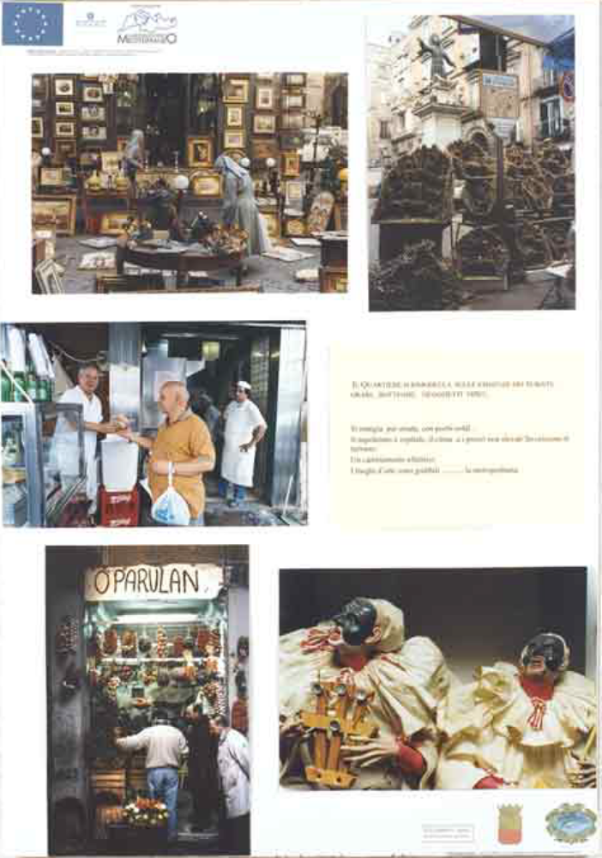

Naples, Florence, Berlin: Three European metropoles, whose historical centers impress more by their differences than by their similarities at the first glance. Beyond the differences, however, a closer analysis shows astonishing similarities of the current dynamics of their development. Historical neigbourhoods formerly abandoned to decay have recently experienced an economic boom due to mass tourism and gentrification. The result was a temporary increase in profit rates for investments and a radical transformation of the social structure. Other more marginal histroical neigbourhoods are showing the opposite process: Socio-economic degradation by the rising rate of unoccupied housing and the departure of wealthier groups of inhabitants.
The exhibition shows some results of our field research regarding the influence of mass tourism on the quality of urban life in the historical centers of Naples, Florence and Berlin. In addition, methods of participative neigbourhood development are presented by investigating examples of city quarter management that took place in traditional Berlin neigbourhoods at risk of degradation
The show is set up according to the concept of "citizens' exposition" or "photo dialogue". The accompanying texts are presented in German, English and partly in Italian
Prior to the conference, the exhibition has travelled in modified and updated versions to:
- Naples: December 2002 (Ex Refettorio di San Domenico Maggiore/Fondazione Laboratorio_Mediterraneo)
- Florence: September 2003 (Chiostro dell'Ammanati - Santo Spirito)
- Berlin: November - December 2003 (Willy-Brandt-Haus)
The documentation of the exhibition and the accompagning community psycological research projects in Naples and Florence/Berlin respectively are available in two separate publications (available at a special prize for participants of the conference at the exhibition).
Time & Location:
16.9. – 19.9. 2004 9 a.m. – 6 p.m. (19.9. closing 2 p.m.)
(Opening ceremony: 16.9. 12.45 a.m.)
Freie Universität Berlin (FUB)
Henry-Ford-Building
Garystr. 35
D-14195 Berlin-Dahlem, Germany

